**Sprint-3**

|  |  |
| --- | --- |
| Team ID | PNT2022TMID47995 |
| Project Name | Smart Fashoin Recommender Application |
| Team Membes | M.reka  G.pooja  P.vaisali  A.ajitha |

1.Create a Bucket in IBM object storage.

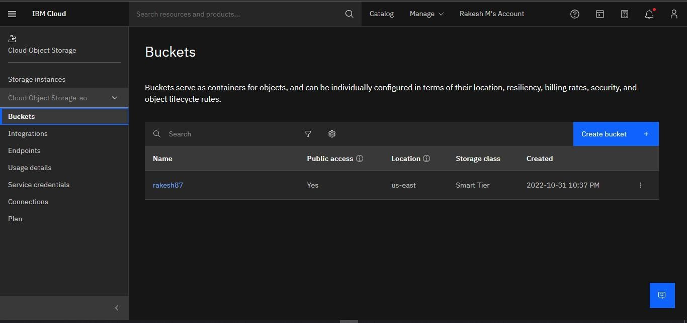

2.Upload an 5 images to ibm object storage and make it public. write html code to displaying all the 5 images.

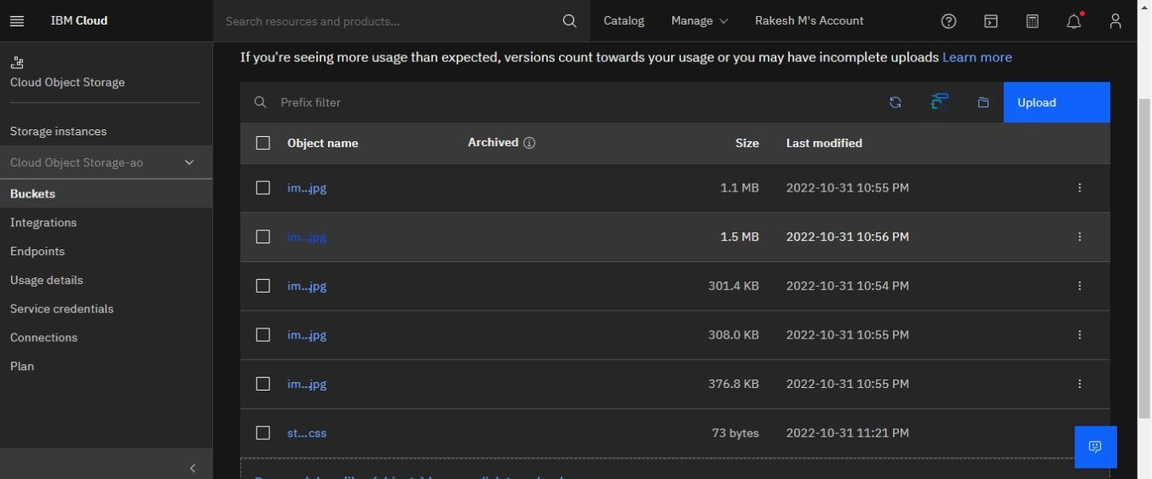

# Assignment3.html

<!DOCTYPE html>

<html lang="en">

<head>

<meta charset="UTF-8">

<meta http-equiv="X-UA-Compatible" content="IE=edge">

<meta name="viewport" content="width=device-width, initial-scale=1.0">

<title>Document</title>

<link rel="stylesheet" href="https://rakesh87.s3.us-east.cloud-object- storage.appdomain.cloud/style.css">

</head>

< body>

<img src="https://rakesh87.s3.us-east.cloud-objectstorage.appdomain.cloud/img1.jpg " alt="">

<img src="https://rakesh87.s3.us-east.cloud-objectstorage.appdomain.cloud/img2.jpg " alt="">

<img src="https://rakesh87.s3.us-east.cloud-objectstorage.appdomain.cloud/img3.jpg " alt="">

<img src="https://rakesh87.s3.us-east.cloud-objectstorage.appdomain.cloud/img5.jpg " alt="">

<img src="https://rakesh87.s3.us-east.cloud-objectstorage.appdomain.cloud/img4.jpg " alt="">

</body>

</html>

3. Upload a css page to the object storage and use the same page in your HTML code.

Style.css

img{

text-align: center; height:250px; width:250px;

}

# Assignment3.html

<!DOCTYPE html>

<html lang="en">

<head>

<meta charset="UTF-8">

<meta http-equiv="X-UA-Compatible" content="IE=edge">

<meta name="viewport" content="width=device-width, initial-scale=1.0">

<title>Document</title>

<link rel="stylesheet" href="https://rakesh87.s3.us-east.cloud-object- storage.appdomain.cloud/style.css">

</head> <body>

<img src="https://rakesh87.s3.us-east.cloud-objectstorage.appdomain.cloud/img1.jpg" alt="">

<img src="https://rakesh87.s3.us-east.cloud-objectstorage.appdomain.cloud/img2.jpg" alt="">

<img src="https://rakesh87.s3.us-east.cloud-objectstorage.appdomain.cloud/img3.jpg" alt="">

<img src="https://rakesh87.s3.us-east.cloud-objectstorage.appdomain.cloud/img5.jpg" alt="">

<img src="https://rakesh87.s3.us-east.cloud-objectstorage.appdomain.cloud/img4.jpg" alt="">

</body>

</html>

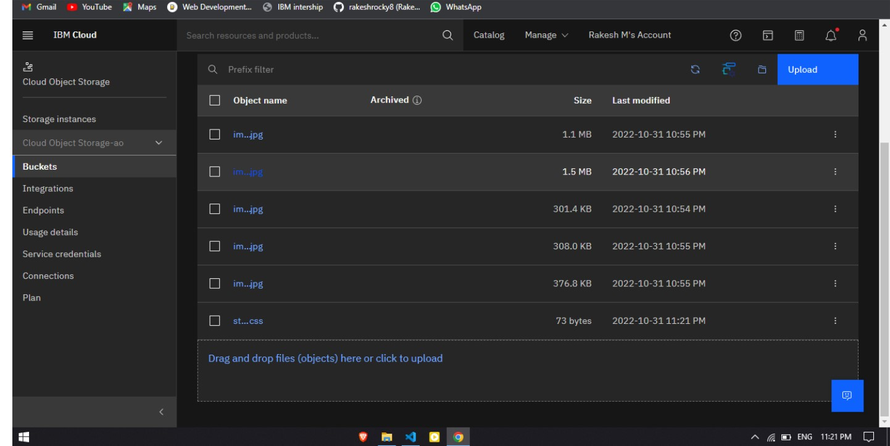

4.Design a chatbot using IBM Watson assistant for hospital. Ex: User comes with query to know the branches for that hospital in your city.

Submit the web URL of that chat bot as a assignment.

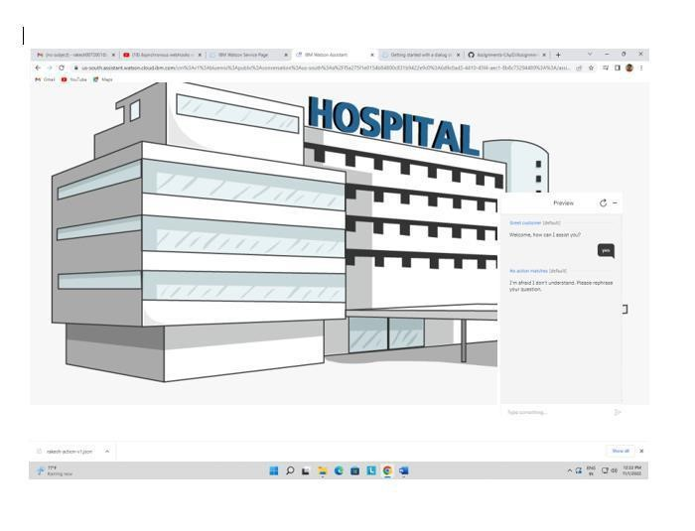

5.Create Watson assistant service with 10 steps and use 3 conditions in it. Load that script in HTML page.

